
October 2009 Volume III, No. 5
Among Friends

WELCOME,  NEW MEMBERS  Katayun Barmak  Phyllis Beardsley  Barbara Carpenter  Eileen Chasens  Yehuda Clark  Barbara Craven  The Deray Family  Diana Dill  Jana Finder  Edwina Frampton  Bernice Hayes  Sarah Heineman  Verna Johnson  Beatriz Kanterewicz  Gena Kashak  Kathleen Kennedy  Debbie Levy-McKenney  Carolyn Linder  Samantha Linder  Marion Cory Lund  Varsha Shridhar  Cleo Smith  Judi Snider  Laure Swearingen  Jessica Wolfe  Join us at our regular  Friends Meetings  Saturdays at 10 a.m.  October 3rd  November 7th  December 5th    all are welcome | With the coming of fall, we are ready to pick up the pace. One of the ways in which you can celebrate fall is by volunteering for our library. The Squirrel Hill Friends of the Library has between six and eight book sales every year. These sales raise a lot of money for the library, but preparing for them takes many hours of work. Sorting books is one of the most important volunteer tasks listed on the Friends membership application, and we hope that it is something you can help us do. Book sorting is not a hard or involved task – it’s actually quite simple – but it desperately needs to be done! Even just an hour spent sorting would be appreciated.  We will have training on book sorting every Monday afternoon in October from 1:00 pm to 3:00 pm. If you are available during this time, we welcome your attendance. If you have any questions, please email Pat Bender at oursounds@msn.com.  During this time of economic struggle, while the library is fighting to maintain its operations, it is most important that we do all we can. Our book sales used to raise money to add extras, like the computer chairs and shelving for new DVDs, that our library could otherwise do without. Now our book sale money is going to supply some basic materials like the DVDs themselves. We know that we can depend on you, as a Friend of the library, to help to make our book sales a success!
  PRESIDENT’ S  MESSAGE  by Joan Schwartzman  The leaves on the trees are starting to change color, the weather is cooler, our children (and grandchildren) are back in school - summer is almost over. | 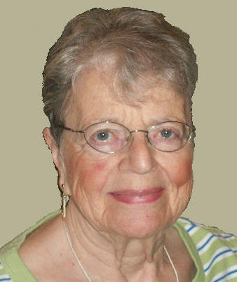
All Free Library of Philadelphia Branch, Regional and Central Libraries Closed Effective Close of Business October 2, 2009
See page 5 for “LATE
BREAKING NEWS”

All Free Library of Philadelphia Customers,

We deeply regret to inform you that without the necessary budgetary legislation by the State Legislature in Harrisburg, the City of Philadelphia will not have the funds to operate our neighborhood branch libraries, regional libraries, or the Parkway Central Library after October 2, 2009. read the rest at http://libwww.freelibrary.or/closing/.
No one is useless in this world who lightens the burden of it to anyone else.
Charles Dickens 1812-1870

Published by the Friends of the Squirrel Hill Library, 5801 Forbes Avenue,Pittsburgh, PA 15217
website: www.clpgh.org/locations/squirrelhill e-mail: Friends@pittsburghusedbooks.com
editor: Joan Schwartzman production: Margie Spenser, Marion Damick,
mailing list: Margie Spenser Dean Damick, Leigh Anne Vrabel, Serena Spenser
October 2009 Among Friends Volume III, No. 5

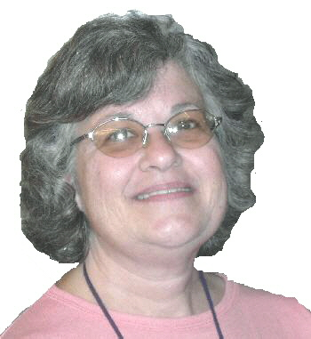  Susan Hughes  Sr. Children’s Librarian | Children’s Department Fall Happenings  Our children’s room was a popular destination this summer. Our summer reading program, “Be Creative”, drew a lot of enthusiastic readers. Over 800 children participated, reading over 6,000 books.  Through the continued support of the Friends of the Squirrel Hill Library, the “Read to Give” aspect of our | Magazines For/About Kids  The children’s department subscribes to a number of great magazines, some for children, some for parents, caregivers, and teachers. Subscriptions include:  - The Mailbox; Idea Magazine for Teachers Preschool edition. Lesson plans and creative ideas!  - Parenting: the School Years Help with school and peer issues.  - Parenting: the Early Years Tips and articles geared for parents of young children  - Scholastic Parent and Child Monthly age specific columns for birth to tweens.  - Family Fun Lots of seasonal ideas to make family life fun and creative.  - Muse Science games and pie throwing.  - Zoobooks Each issue highlights a type of animal.  - Ask Arts and science for kids.  - Creative Kids: the National Voice for Kids Games, art, stories, poetry, and opinions by and for kids ages 8–14.  - New Moon Girls Articles about girls: problems, interests and dreams. Kids can submit articles and art work.  - Wild Animal Baby Small durable publication perfect for toddler hands, with lots of pictures of animals.  All magazines, even the most current issues, can  be checked out for three weeks. Stop by the  children’s department and take a look.  Books are the quietest and most constant of friends; they are the most accessible and wisest of counselors, and the most patient of teachers.  Charles W. Eliot- 1834-1926  so is there anything else we can put here?  Children’s Programs:  Weekly  Family Storytime  Mondays at 6:00 PM, Saturdays at 11:00 AM  Toddler Storytime  Tuesdays at 10:30 AM and 11:30 AM  Baby Lapsit  Thursdays at 10:30 AM and 11:30 AM  Monthly  Origami: Saturdays: Oct. 17, Nov. 21, Dec.19  Beginning Origami at noon  Advanced Folding at 1:30 pm.  Presented by The Origami Club of Pittsburgh. Come join the fold!
Summer Reading Clubs gave $225.00 to the Animal Rescue League of Western PA, based on how many books were read. Thank you to the Squirrel Hill Friends for making it possible for us to buy prizes and provide special programs!

The library staff would like to officially welcome Gwen, who joined us at CLP – Squirrel Hill in June. Gwen is enjoying her time at Squirrel Hill while her “home” library, CLP – East Liberty, is closed for renovations. Since she is a Jack of all trades, if you can’t find Gwen in the children’s department, look in adult reference or at the circulation desk.

Special Programs
Please register online at sqhillchildrens@carnegielibrary.org.
or call us at 412-422-9841
Halloween Fun – Monday, October 26 at 6:00 PM. Stories, games and activities. Come in costume. Family Fun for all ages!

Cloudy With a Chance of Meatballs – Sunday, November 8th at 2:00pm. Family fun designed around this clever picture book/movie by Judi Barrett. Science, games, a craft and stories. All ages.

Check out www.carnegielibrary.org/kids/happening/ for more fun programs.

New Books Not to Miss:
New Picture Books
Fox Hello Baby! Lots of baby animals.
Polacco In Our Mothers’ House Two Moms create a loving home.
Winget Tucker’s Four-Carrot School Day First day of school.
Boutignon Not All Animals Are Blue; A Big Book of Little Differences
Interactive for child and adult.
Spinelli When Papa Comes Home Tonight A child and father’s end-of-the-day routines.
Williams Horse In the Pigpen Farm chaos in rhyme.

Great New Fiction
Rodgers Freaky Monday Sequel to the classic, Freaky Friday.
Holt Mike Stellar: Nerves of Steel A journey to Mars.
Golding Den of Thieves: Cat Royal Book 3 Travel to the French Revolution.
Lin Where the Mountain Meets the Moon Dragons and magic fish.
Carey, B. The Unknowns: a Mystery 11 yr. olds follow math clues to find missing residents.
Leal Also Known As Harper A 5th grade girl copes with hard times through poetry.

New Non-Fiction
Cook Our Children Can Soar: a Celebration of Rosa, Barack, and the Pioneers of Change
Jules Unite or Die: How 13 States Became a Nation
Smith Mother Poems
Silvey I’ll Pass for Your Comrade: Women Soldiers in the Civil War
Bruchac The Girl Who Helped Thunder and Other Native American Folktales

2

October 2009 Among Friends Volume III, No. 5
 | Film, Fiction, Fun  third Thursday  of the month  from 1 to 4 p.m.  lead by Jeanne Bergad
October 15
Madame Bovary
November 19
The Maltese Falcon
December 17
The Haunting of Hill House
(The Haunting)
& The Lottery (if time allows)
  Art at the  Squirrel Hill Library  -  Coming up are:  October: Jeanne Bergad  portraits  November: Cathy Wencil  acrylics  December: Mary Ellen Meyer Pen & Ink and Pastels  and  Maureen Hahn  portraits  Our schedule is full through October, 2010! If you’d like to exibit after that, contact Marion Damick,412-521-3075.  Potpouri: :  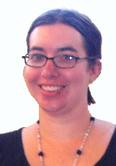 | Film, Fiction, and Fun is a special series presented at the Carnegie Library of Pittsburgh -- Squirrel Hill that explores the relationship between films and the novels that inspired them. Attendees are encouraged to read a monthly fiction selection, and then join CCAC’s Jeanne Bergad for a screening of the film and discussion to follow.  October 15th’s title is Madame Bovary, by Gustave Flaubert. Published in 1857, Flaubert’s first novel satirizes the excesses of the middle class. The title character, a housewife with romantic fantasies, spends beyond her means and engages in extramarital affairs to relieve her boredom with provincial life. Following the novel’s publication, Flaubert was accused of obscenity by public prosecutors, resulting in a scandalous trial and Flaubert’s eventual acquittal. The 1949 film starred Jennifer Jones and Van Hefflin.  November 19th’s selection is The Maltese Falcon, by Dashiell Hammett. In this classic mystery novel, the iconic detective Sam Spade becomes a pawn in a complicated game of betrayals and double crosses, all for the sake of an immensely valuable gold statuette in the shape of a falcon. The 1941 film version was the directorial debut of John Huston, and it starred Humphrey Bogart, Mary Astor, Peter Lorre, and Sydney Greenstreet. Although Bogart’s depiction of Sam Spade is one of his most famous roles, he did not receive an Oscar nomination for Best Actor. However, stage actor Greenstreet (in his very first film role) received a nomination for best supporting actor.  December 17th’s title is The Haunting of Hill House, by Shirley Jackson. Published in 1959, this classic ghost story follows the efforts of Dr. John Montague to find and document supernatural activity within Hill House, an old mansion with a history of violent death. Stephen King has named this book as one of the best horror novels of the 20th century, and one can see its influence in King’s own novel, The Shining. Jackson’s story was brought to film in 1963, simply entitled The Haunting. The movie was directed by Robert Wise, and it starred Julie Harris, Claire Bloom, and Richard Johnson.  Time and circumstances permitting, Shirley Jackson’s short story The Lottery (and the film version) will also be viewed and discussed.  A house without books is like a room without windows.  No man has a right to bring up children  without surrounding them with books…  Children learn to read being in the presence of books.  Horace Mann 1796-1859
   | Film,  Fiction,  Fun  by Mark Russell, Librarian | 
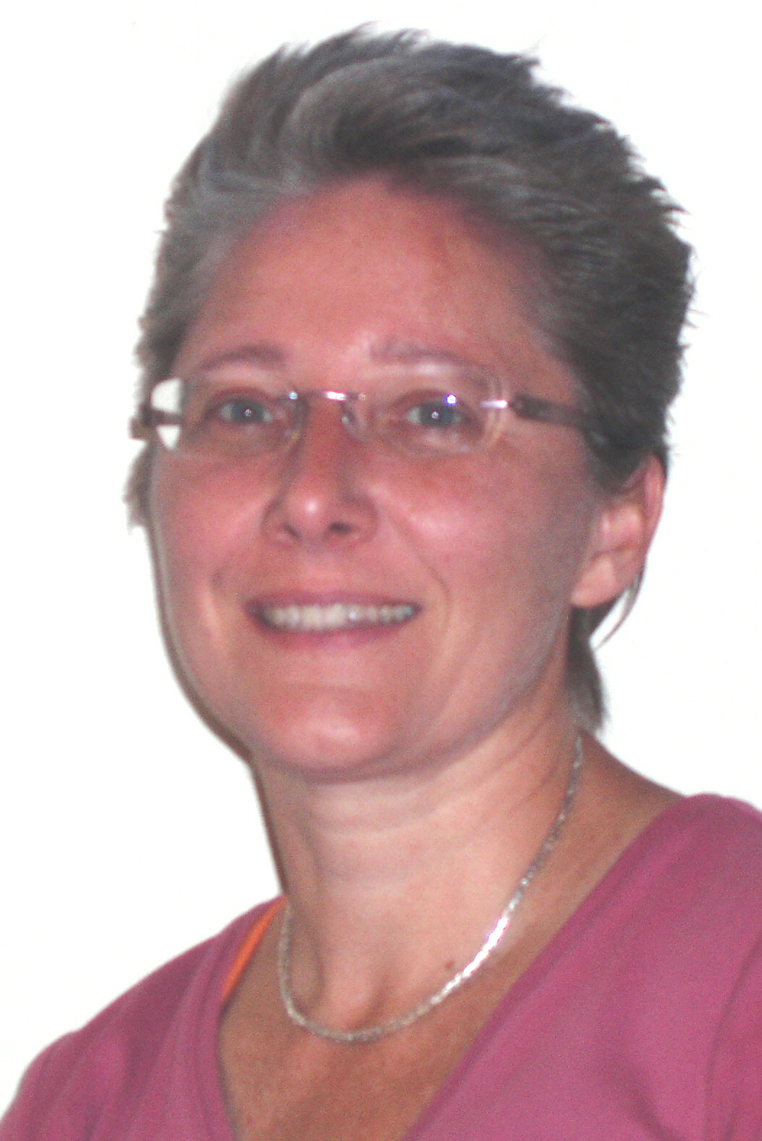  Gwen  Library Assistant &  Information Goddess
  In 2007, 7 billion pounds of plastic bottles went into landfills. How much space did that take? Imagine the Greenfield Giant Eagle stretched to Forbes Avenue -- with the front door at the Squirrel Hill Library, one corner at South Dallas and one at the Schenley Park golf course -- and filled with plastic bottles.That was in 2007, and sales of bottled water keep rising. By now, we might need to imagine our 2-story Library building stretched to cover that same square mile. What about reusing plastic bottles for tap water? Saves landfills, but old plastic bottles may leach into your drink and cause cancer or brain damage. It’s time to buy a stainless steel water bottle. Most important, profits go to the Carnegie Library. It’s a great gift for any age. |   comes with a  carabiner (clip)  for your belt or  backpack strap

Jennifer McKinney
Children’s Librarian

9/18: A customer signed up today for a family donor card. The staffer helping her pointed out that she had put an extra 0 at the end of the $50 on her check. She thanked him but said it was not a mistake. Way to go!

3
October 2009 Among Friends Volume III, No. 5

 | Books, BOOKs,BOOKS,BOOKS,BOOKS,BOOKS,BOOKS,BOOKS,BOOKS,BOoks,  as of September 21, 2009:  This issue of the newsletter has been a nightmare to produce. We start a month ahead because we print more than 3600 pages twice – black text on 4 inkjet printers connected to my computer (because I refill ink cartridges, saving hundreds of dollars) and color parts on the Library’s laser printer, which makes much prettier pictures. It’s been agony deciding which pages to print and which to hold while the budget process drags on. I’ve rewritten this column five times. On 9/19, the governor and the leaders of the General Assembly agreed on a balanced budget, but haven’t released amounts for any line items. It will take 10 days to two weeks to print up the bills and take votes; apparently there may still be changes |   by Margie Spenser  Book Sale  Committee
and compromises during that time. (See page 5 for LATE BREAKING NEWS.) We must keep reminding our legislators that Pennsylvanians deserve better. It’s also time to think about the next several years: What can we do to develop more ways to fund local libraries? Perhaps CLP should sell naming rights to branches, programs, or rooms. The endowment fund is ludicrously small (less than $8 million dollars). The city of Pittsburgh still kicks in the same $40,000 they did 114 years ago.

On a happier note: Our Friends have been responding to our calls to action. In August, a 17-year-old Friend wrote a thoughtful and articulate essay (below) that was featured in the My Generation section on the Post Gazette comic pages, then published on the PG website as a letter to the editor. (See page 6 for letters published in September.) Our branch manager, Holly McCullough, received a letter last week from a customer who enclosed a check for $500. Our legislators reported a deluge of letters urging them not to cut library funding. Please don’t stop now!

Our July Fiction, Foreign Language, and A/V sale made $1,844 and gained us more than 20 new members. It was a beautiful weekend for the Squirrel Hill Sidewalk Sale, which is starting to have more participation by the merchants; the aim of their organization is to build it back up to a special event like the old Squirrel Hill Happening.

The flyer on page 8 for the October sale has a note in the middle that is too small to read. It says:
Nonprofit organizations are invited to apply for our Free Bags program.
You will be issued up to 3 name tags that will allow the wearer to select books for your school, shelter, library, free books
program, etc. during the bag sale on Sunday and Monday. Please register early and explain how you plan to use the books. friends@pittsburghusedbooks.com or 412-521-4129

Please let me know of any organization that might qualify, or pass this along to them. Thanks.
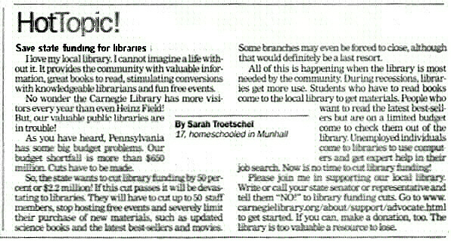

Children don't read to find their identity, to free themselves from guilt, to quench the thirst for rebellion or to get rid of alienation. They have no use for psychology.... They still believe in God, the family, angels, devils, witches, goblins, logic, clarity, punctuation, and other such obsolete stuff.... When a book is boring, they yawn openly. They don't expect their writer to redeem humanity, but leave to adults such childish illusions.
Isaac Bashevis Singer

m
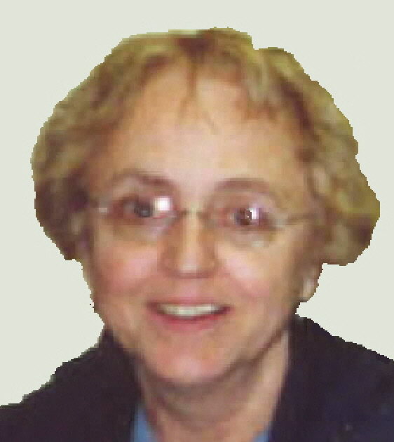 | MINI  SALE  NEWS  by Pat Bender  mini-sale chair | We have just completed the September sale of books on religion and philosophy. The total income from that sale and the accompanying boutique was $680. Thank you to everyone who helped with the sale and to our patrons for their support.  We also had a boutique at the July sidewalk sale. It earned $300. It was extremely satisfying that the boutique was so well received. Many thanks to Shirley Streff who donated beautiful handmade tote bags to the sale.
The October sale, one of our major events, is on the horizon and we are planning a boutique. Since the seasons are changing, we will have many new items for cooler weather for adults and children.
October is also the start of the book room tutorials on how to stock the ongoing book sale shelves, to be held from 1:00-3:00 p.m. every Monday afternoon. I will be in the bookroom all those times and look forward to seeing you.
In this time of financial cutbacks to libraries, the Friends feel that one of the best things we can do is facilitate our ongoing sale with frequent stocking.
4

October 2009 Among Friends Volume III, No. 5
 |  | NAMM BUSINESS CENTER PROGRAMS  October – December 2009  by Dorothy Kabakeris, Namm Business Center Librarian  All programs are scheduled for Wednesday  from 10:15 AM – 11:00 AM except where indicated | 

Oct 14 at NOON Search for Job Opportunities Using the “Pittsburgh Business Times”
Learn techniques for today's professionals for finding non-advertised job opportunities, networking for employment and tracking
potential employers. It is difficult for professionals to know where to begin when they find themselves starting over.
Use a strategy that will not only help you get started, but will build your career in the future.
Presented by Chris Engler, Pittsburgh Business Times

Oct 21 at 1 PM In the Market to Buy a House?
Get a "heads-up" about the forms to be filed, keys to successful negotiating, realty jargon and the kinds of decisions you will need
to make. And if you are a 1st time buyer, hear about the $8,000 tax credit Uncle Sam is offering until December 1, 2009.
Learn the basics in home-buying before or during your search. You could be saving time and money!
Presented by Lois Harkness, Realtor, WHY USA Homes For U Realty

Oct 28 Get P.A.I.D.
A guide for businesses to getting paid faster (and what to do if you don't). Businesses desiring payment must give credit wisely.
Learn the system where you as a business or credit manager can increase profits and reduce costs & delays,
while developing better relationships with customers by using a successful four-step method.
Presented by Robert S. Bernstein, Attorney, Bernstein Law Firm.Oct 21 at 1 PM

Nov 18 Ten Estate Planning Mistakes or Misconceptions
Learn the financial truths that can save your nest egg!
Presented by Thomas Crowley, J.D., Vice President & Senior Wealth Planner, PNC Wealth Management

Dec 9 Practice The Creative Steps To Staying Fit In The Workplace
Presented by Mark Haffner, AFAA certified Personal Trainer & Life Coach, President: On Your Mark for Life

Dec 16 Promote Your Business in a Fluctuating Economy
This interactive session will help you develop a strong marketing strategy. You will identify the specific "choke-point" behaviors that
are killing your promotions while pinpointing simple marketing patterns that will keep business coming through your door.
Presented by Crystal Bynum, Bynums Marketing & Communications, Inc.
The Squirrel Hill Adult  Book Discussion Group  All are Welcome.  Thursday, October 22 1:00 PM  Gift From the Sea  by Anne Lindbergh, 1954  Wednesday November 19 1:00 PM  Road from Coorain  by Jill Kathryn Conway, 1990  December – no meeting  The monthly Namm newsletter lists our business programs and new business titles. To have it sent to your computer,  email us at: squirrelhill@carnegielibrary.org. | It’s never safe to be nostalgic about something  until you’re absolutely certain  there’s no chance of its coming back.  Bill Vaughn- 1915-1977
LATE BREAKING NEWS
Philadelphia’s website notice to customers that the library would have to close completely was
pretty scary, wasn’t it? Their money problems apparently go far beyond the libraries. Just
before the state budget was tentatively agreed on, the Governor signed a bail-out deal with the
city. Pittsburgh’s in such great shape that there’s no chance of a sudden miracle like that for us!

The budget Rendell vowed to veto on 9/14 called for a 33% cut in funding for local libraries, and even
bigger cuts for statewide library functions – as much as 70%. On 9/18 an overall state budget deal was
reached but budget line item details remain under wraps. Staff people continue to work on the budget’s
specifics. Until details become public, some adjustments to specific line items within the broad
agreement are still possible.. A constant drumbeat of calls and emails might just help us
even at the 11th hour.
Call or e-mail the Governor and your legislators. Tell them that cuts this enormous are not fairly sharing
the pain but, in fact, unfairly making libraries shoulder the burden. Here’s a phone list:
http://palibraries.org/displaycommon.cfm?an=1&subarticlenbr=230. Here’s a link to some background
and a sample message that you can edit and send with one click:
http://www.capwiz.com/ala/pa/issues/alert/?alertid=14045271.
Pittsburgh Post Gazette, Sunday, 9/27: “a vote on the 2009-10 budget is at least a week away”
5

October 2009 Among Friends Volume III, No. 5 July 2009 Among Friends Volume III, No. 3
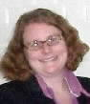 | the headline hardly changes:  Budget Crises and the Future of the Carnegie Library of Pittsburgh  By Holly McCullough, Manager, Carnegie Library of Pittsburgh – Squirrel Hill  25 days into September, we still are faced with uncertainty regarding the budget. We know that public libraries are facing substantial cuts. The latest news puts the figure around a 38% cut from the state. Over all, CLP is facing up to a $3 million dollar reduction in our $23 million dollar budget for 2010.
Here are some other things we know:

- About 92% of the library’s operating budget comes from public funding.
- The Carnegie Library of Pittsburgh received no endowment from Andrew Carnegie.
- The Regional Asset District (RAD)(1% county sales tax) provides over 70% of our funding.
- CLP has submitted its funding request to the Regional Asset District for 2010 and has asked for a 10% increase to help cover some of the expected shortfall from the state.
- The RAD will adopt a preliminary 2010 budget in October.
- The library faces a $6 million dollar budget gap by 2013.
- The library’s board of trustees will announce details the first week of October of how it plans to deal with the budget crisis. Plans will most likely include the closing of some neighborhood locations.

The next CLP board meeting is Monday, October 5th. Details of what they decide will be announced to the staff and public on October 6th, with a meeting of all staff members being planned for that morning in Oakland. The administration and board of the library are looking not only for solutions to the crisis that the library faces for 2010, but for long-term answers to the growing gap between revenue and expenditures. Immediate reductions in the size and scope of services across the city are likely; specifically, cutting the number of neighborhood locations. The direct result of any location closures will be less access for children, teens, and seniors to books, computers, librarians, and information. In addition, any location closure impacts not just that neighborhood but all remaining locations, as the burden upon those staying open increases.
The Squirrel Hill location has experienced a 9% increase in use from last year (which was our busiest year on record) and usage continues to rise. Nevertheless, we face a number of potential cuts including: a significant reduction of hours, which may include closing one or two days a week; reduction of staff; significant reductions in new items for the collection; cuts in outreach to schools and daycares; and a reduction in programs and services. I hope that everyone reading this realizes the severity of the situation.
To keep these scenarios from becoming a reality, I urge you to continue to do everything you can to Protect Your Library.* We have seen a definite increase in donations over the last several months, which is encouraging, but giving to the library needs to grow substantially in order to make a difference. The state budget details change daily. Calls to your local State representatives and the Governor’s office still have a chance to make a difference. Please visit www.carnegielibrary.org to find out what to do and how to spread the word to others.
These letters were published in the e
. For news articles& more letters, search www.post-gazette.com for libraries.
September 2  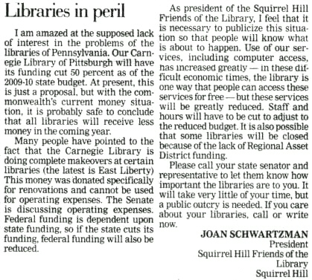  Let the people know the truth and the  country is safe. Abraham Lincoln |  | September 10  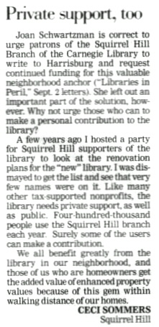  Ceci Sommers, former head of WQED-FM, is a member of the board of the Squirrel Hill Urban Coalition and is involved in many other civic organizations. | September 12  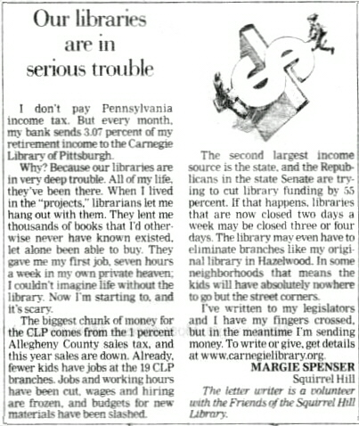
* see page 7 & 8’s “library card” 6

October 2009 Among Friends Volume III, No. 5

The end of summer is upon us and I would like to thank all of the teen volunteers for the help they gave us this summer. With the closing of the East Liberty library for renovations, Squirrel Hill is busier than ever. The teen volunteers played an important role in keeping the books, audio books, and music CDs sorted and shelved. These teens worked their tails off every day, every hour, every moment to keep the staff caught up with many jobs around the library. Squirrel Hill Staff and I would like to give our heartfelt thanks to each and every one; we also want to include the parents in our thank you, for having such dedicated children.  STARS OF SQUIRREL HILL    Teens: TOTAL SUMMER HOURS: 345  Daniel Brusilovsky, Jenna Herbert, Dena Edelman, Chantal Bcaziel, Roza Dinishenskaya, Dimana Dintcheva, Sarah Nemoy, Amery XU, Louisa Fitzgerald, Marigay Norman, Alisha Murray.  Thank you from the Squirrel Hill staff to all of our adult volunteers: TOTAL SUMMER HOURS: 306  Hirsh Wachs, Trudi Wachs, Shari Sweet, Diane Bender, Katherine Wilson, Clementine Solari, Eboni Hines, Daniel Cohen.  Special thanks from the Squirrel Hill staff to the Friends of the Squirrel Hill Library, who run our used book sales to raise money to supplement the library’s budget:  TOTAL SUMMER HOURS: 763  The Squirrel Hill Library is busier than ever. Books, CD’s and DVD’s need to be put on shelves, and I would like to invite anyone who has a few spare hours to come and volunteer at the library to help the staff or the Friends of the Squirrel Hill Library. Senior volunteer Hirsh Wachs will be happy to train you to help in the library. Pat Bender and Margie Spenser will train all who want to help the Friends keep the ongoing book sale shelves full.  THE MORE THINGS CHANGE, THE MORE THEY STAY THE SAME: SSAME:E SAME:AMESAMESAME::SAME | Here’s another “Library Card” – cut it out and keep it handy to remind you to think about how we can raise more money for libraries, now and in years to come:  Pittsburgh, Protect Your Library by doing any  or all of these three things:  • Write a letter to your library funders about  how valuable the Library is to you and how  important sustainable funding is to the Library.  • Give a monetary donation to the Library.  • Talk to a friend about doing the same.
  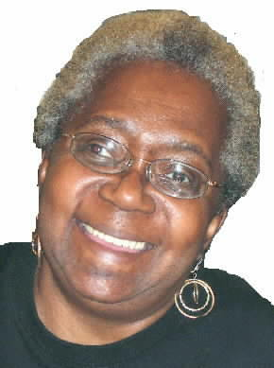 | From the desk of Audrey Hines  Senior Librarian/  Volunteer Coordinator
  for more information visit  www.carnegielibrary.org | 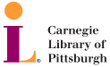
Whatever happens with Pennsylvania and RAD funding this
year, the crisis is not over. Even if city, county, and state
funding stays level with 2008, the gap between funding and
expenses is projected to grow to over six million dollars by
2014. Start brainstorming about funding sources!

Teen Reading Success  by Kim Parker  Teen Librarian | 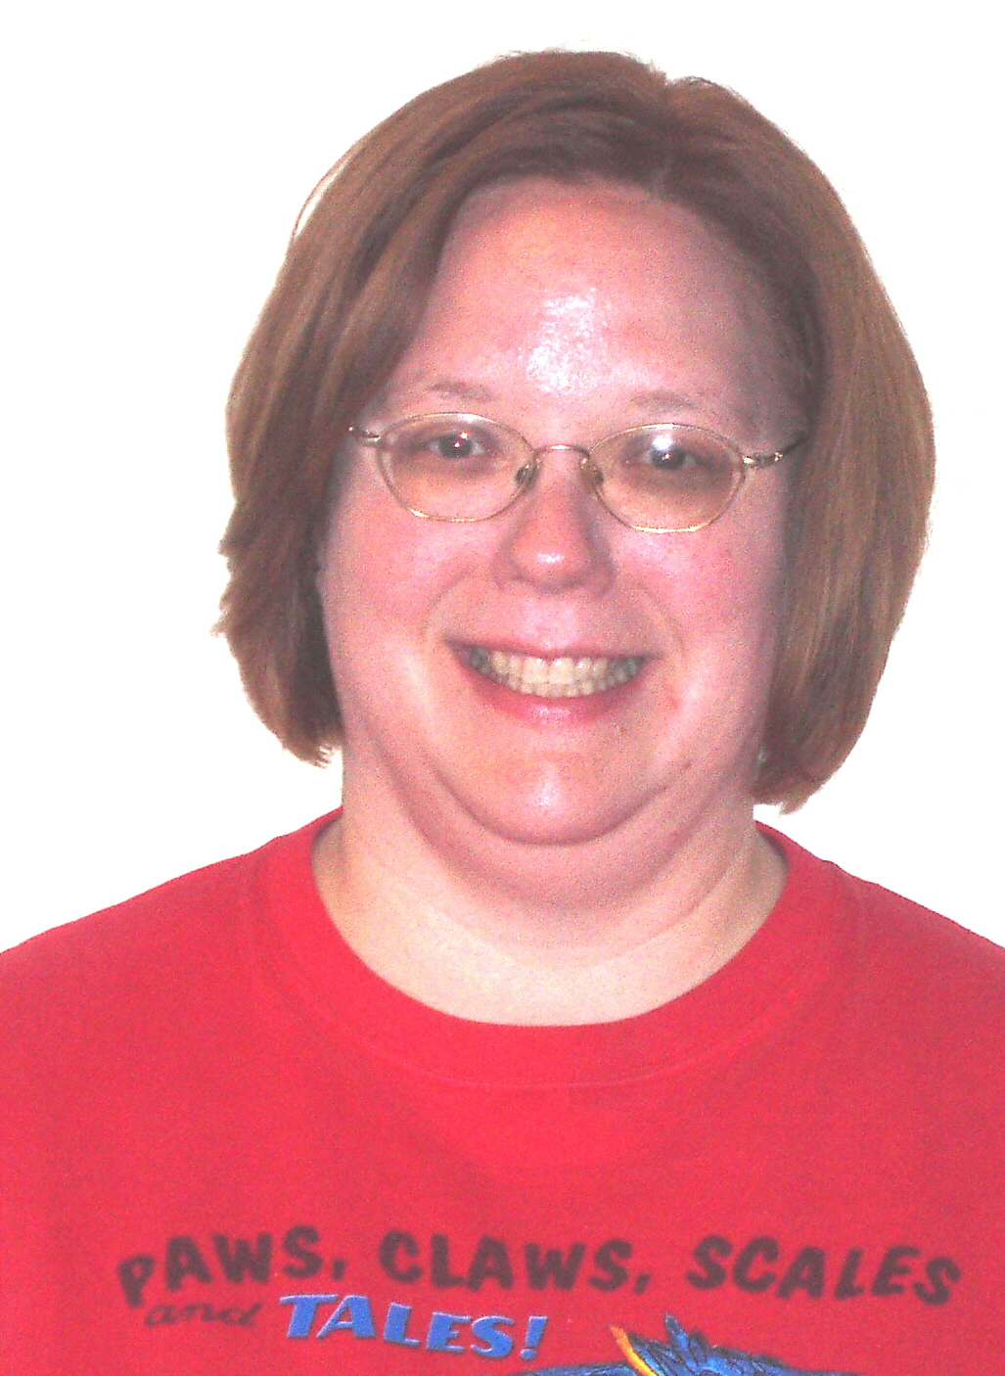
Teen Summer Reading was spectacular this year! Squirrel Hill library had 207 teens taking part in the 10 week program, reading a total of 598 books. These numbers are by far the highest for any Carnegie branch library. Throughout the summer reading program incentives were given; for example, a free book and earbuds were handed out with registration, and $10 gift cards for Target were randomly given out as prizes to teens entering book reviews into the Library’s web site.

In other news, we are excited that Squirrel Hill Library will host another of the Carnegie Library’s Behind Books: Authors Talk to Teens programs. Lauren Myracle, author of ttyl and ttfn, a popular series of books written in an “instant messaging” format, will be speaking at the library on Wednesday, November 18th from 7:00pm – 9:00pm. Space is limited. If you are interested, please register by calling Karen Brooks-Reese at 412-578-2599.

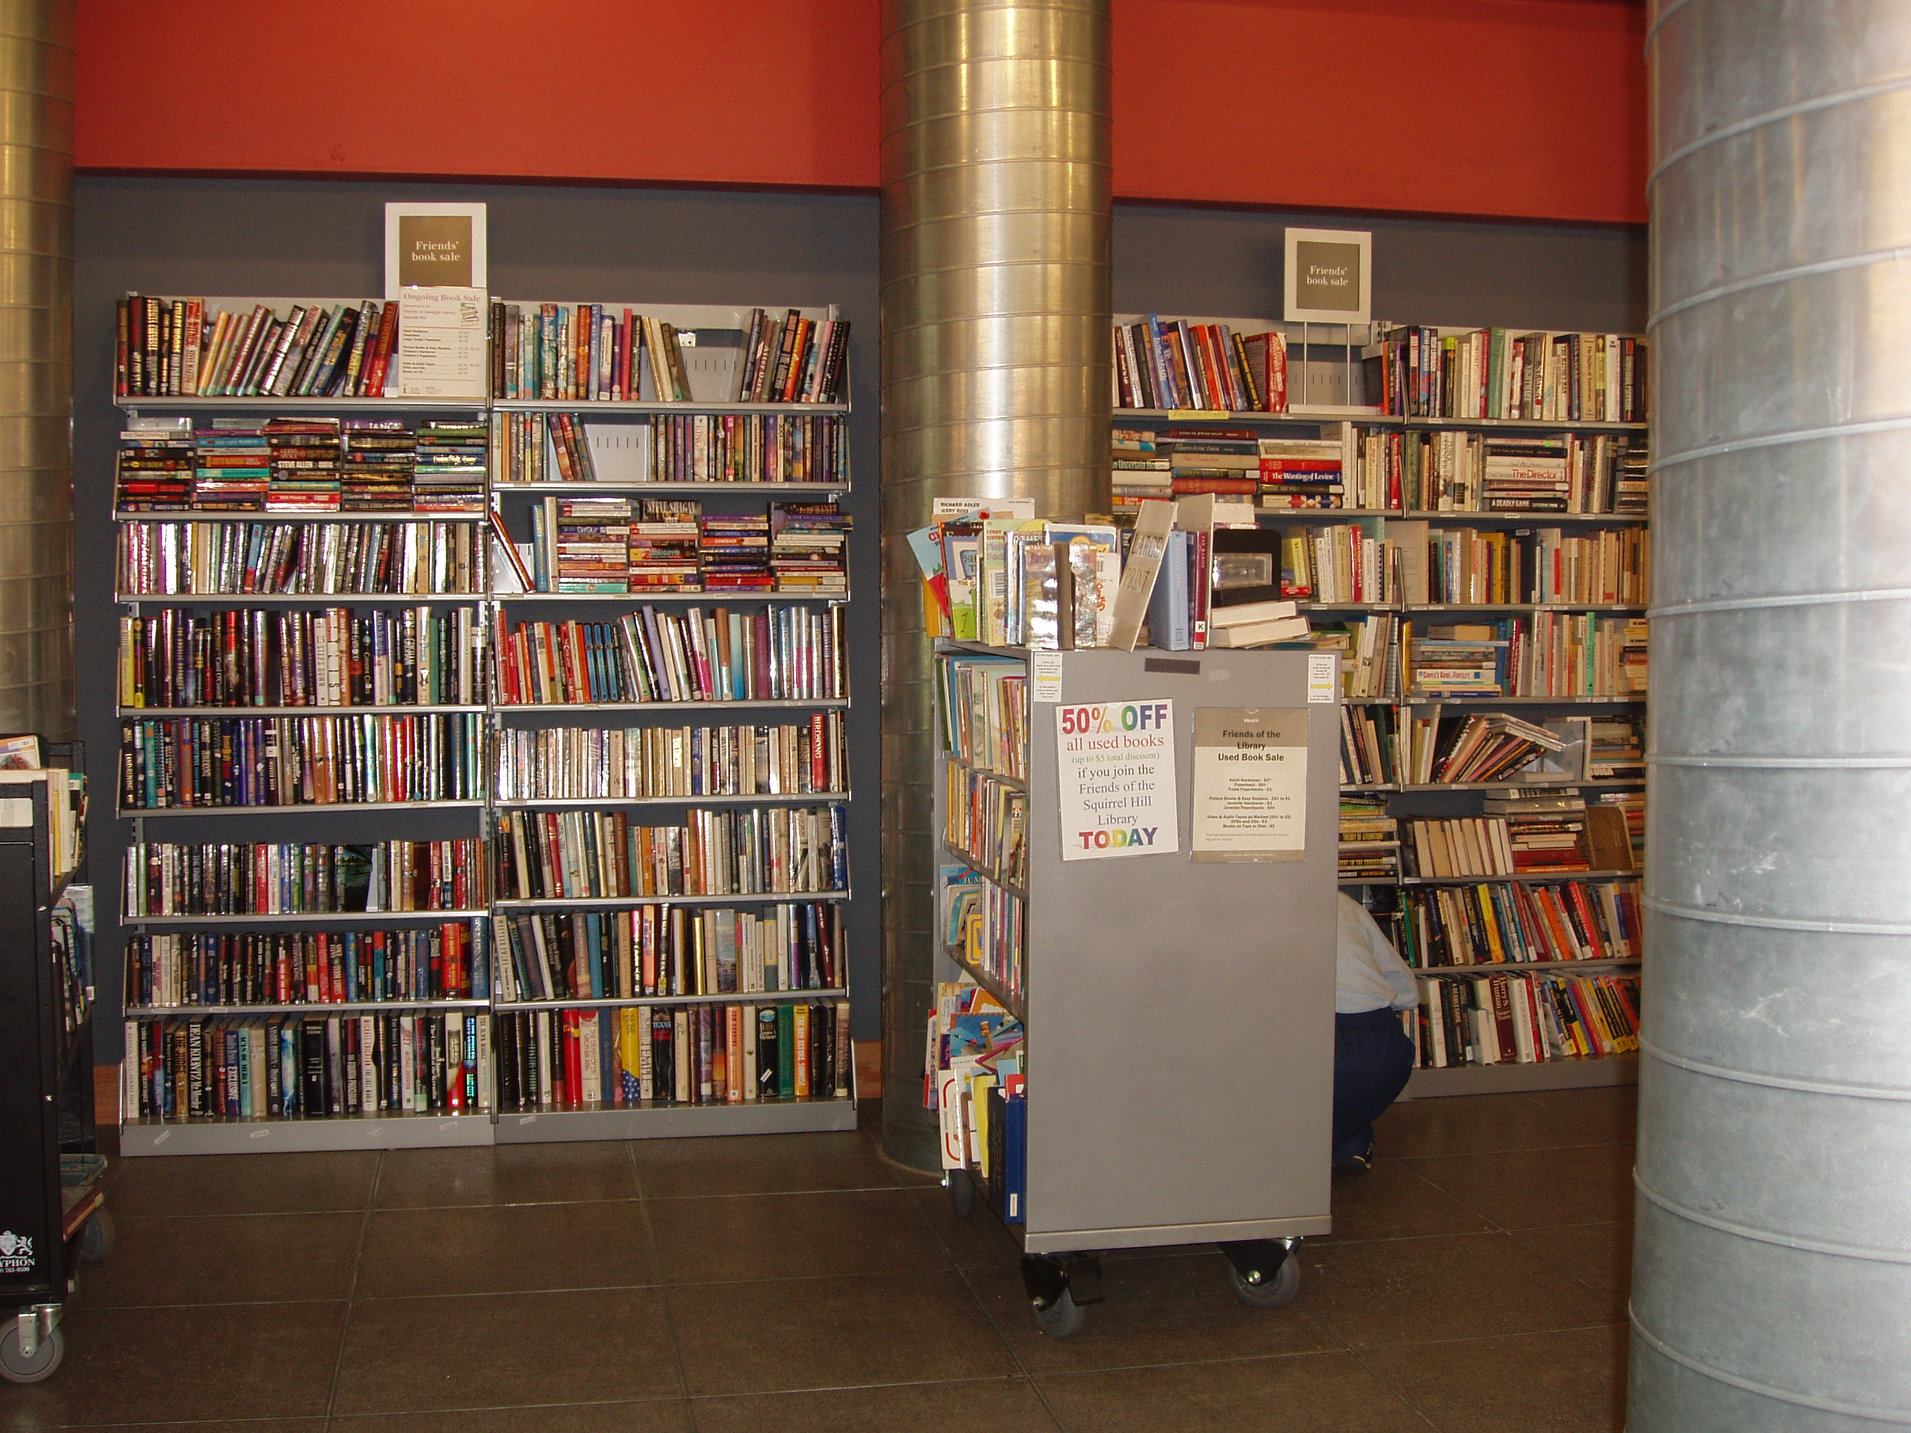

Friends of the Library
raise money to supplement the library budget,
advocate for library funding,
volunteer at the library, and
publicize library programs and events

The Friends of the Squirrel Hill Library
5801 Forbes Ave. Pittsburgh, PA 15217
412-422-9650
www.clpgh.org/locations/squirrelhill
friends@pittsburghusedbooks.com
What do we, as a nation,
care about books?
How much do you think
we spend altogether
on our libraries,
public or private,
as compared with what
we spend on our horses?
John Ruskin- 1819-1900
Ongoing Book Sale

7

October 2009 Among Friends Volume III, No. 5

Did You Know: There is only one state that has a lower state income tax rate  than PA has? If you add income tax to sales tax, there are still 31 states with  higher taxes. For more info: www.pennpbc.org.  . | Make checks payable to:  Friends of the Squirrel Hill Library  and mail to:  Margie Spenser  5900 Douglas St  Pittsburgh, PA 15217  Check one box:  New Member Renewal  Check one or two boxes:  $5.00 $10.00 $15.00  $25.00 Other _____  DONOR (free, but we accept donations)  Name:___________________________________  ^{(Last)} ^{(First)}  Address: _________________________________  City/State: __________________Zip: __________  Phone(s): ___________________Date: _________  E-mail address: ____________________________  Please check all activities you can help with:  Periodic Book Sales Library Advocacy  Sorting Used Books Gardening  Adopt-a-Shelf Program Newsletter  COMMENTS_______________________  ______________________________  Among Friends is now online!  Go to www.pittsburghusedbooks.com  and click on the “Friends” button  Some people drink  from the fountain of knowledge,  others just gargle.  Robert Newton Anthony  1916-2006
   | Below the “library card”  on the left are figures for  the state’s contribution toward our three sexy new “public attractions” and the boring old Library.  How many folks were attracted?  2008 attendance:  PNC Park  (Pirates 1,609,076)  Heinz Field  (Pitt Panthers 296,113; Steelers 503,125);  both stadiums  together 2,408,314  CLP 2,609,653
  State funding for Heinz Field, PNC Park, and the Conven-tion Center was $333,300,000. In 2008, state funding for the Carnegie Library of Pittsburgh was $6,292,292. Less than 2%. To come out even, those three buildings will each have to last more than 50 years... with no further pleas for us to bail out the millionaires. Wanna bet on that?
  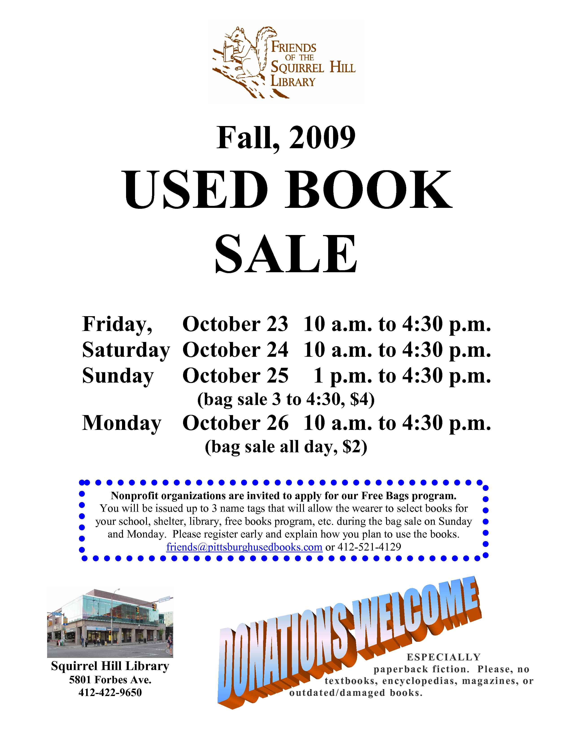 | 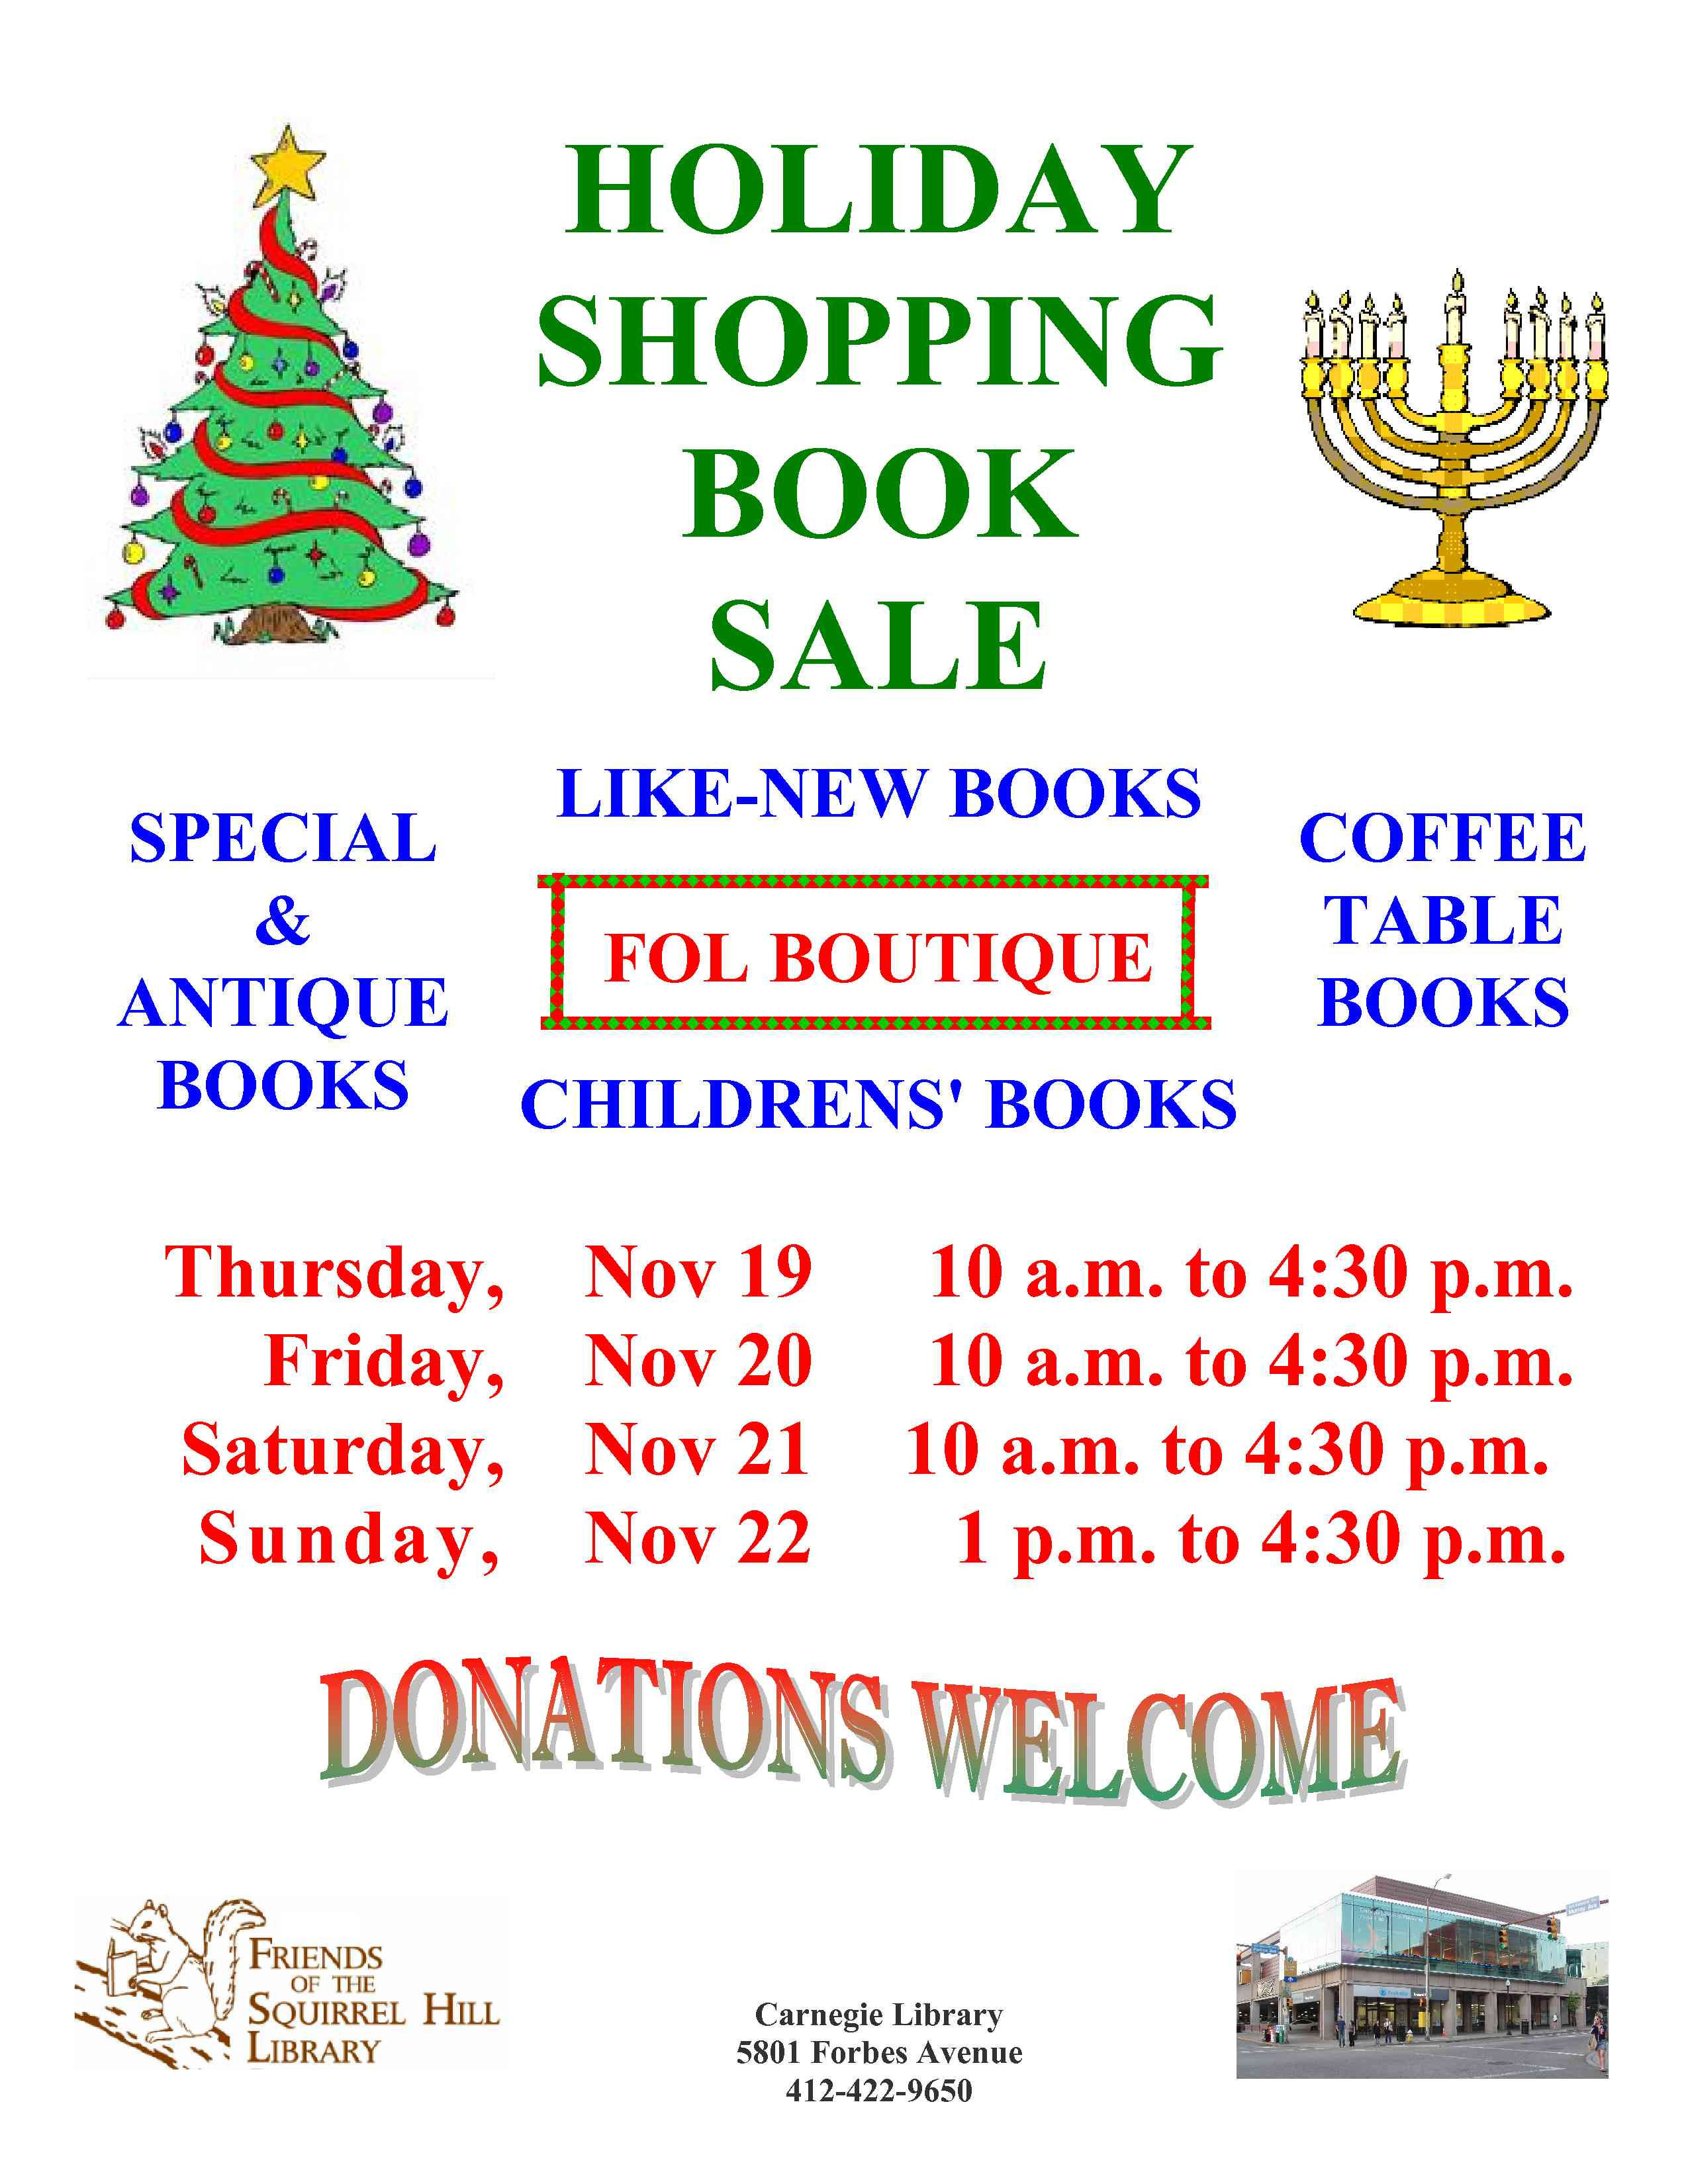

CARNEGIE LIBRARY OF PITTSBURGH  SQUIRREL HILL |  | 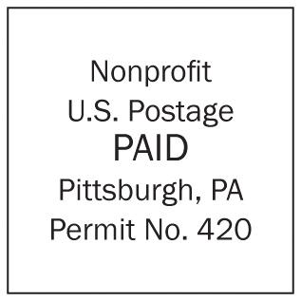
85801 Forbes Avenue  Pittsburgh, PA 15217  Adult Services: 412-422-9650  Children's Services: 412-422-9841  Fax: 412-422-5811  www.carnegielibrary.org/clp/sq  Is your Friends Membership up to date? If the date is before 10/09, you need to renew.  Use the form at top right.  your donation is tax deductible  as a charitable contribution | ADDRESS SERVICE REQUESTED  8
  
  EXPIRES:  MONTH YYYY | NAME  ADDRESS  CITY, ST

